A Church Guide for Choosing Your Next Adventure

This is a guideline of different options available to congregations that are looking at changing courses for the future. It is meant only to help you imagine different futures that are possible in the right circumstances. There may be other creative options not listed. The Committee on Ministry will help you discern the option that is best for your context.

- Called and Installed Pastor/Transitional Pastor
aka “All the Bells and Whistles”

Ideal for congregations that are able to sustain a full time pastor with salary and benefits.

- Part-time Installed Pastor aka “Sure, I’ll help out.”
Ideal for congregations that do not require a pastor available on site or by phone 24/7.
- Merge with Another Church
aka “Two Shall Become One Flesh”

Ideal for congregations that have a good partnership with another, and for congregations willing to let go of their building and grounds to create a new community.
- Federate with Another Denomination
aka “With Our Ecumenical Powers Combined…”

Ideal for congregations with a good partnership with another ecumenical community that is willing to live by and perhaps alternate denominational standing rules and pastors.

- Yoke With Another Church aka “Circuit Rider”

Ideal for congregations willing to share a pastor and support salary and benefits together, and are flexible on their worship times to accommodate a traveling pastor.

- Parish Model aka “What’s Old Is New Again”
Ideal for congregations in close proximity to each other who are willing to partner with multiple congregations and work out a mutual agreement that would include full salary and benefits.
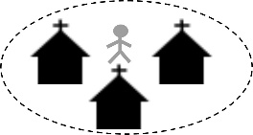
- Pastor-on-Loan aka “Rent-A-Cop” aka “Moon-lighting”
Ideal for churches with a pastor close by that they can borrow on Sundays and for limited pastoral services.
- Nesting
aka “Pfft, who needs a building?” aka “The Way Paul Did It.”
Ideal for congregations willing to let go of their building and grounds to meet in a more cost-effective location. If nesting in another church, perhaps agreeing to a nontraditional worship time.
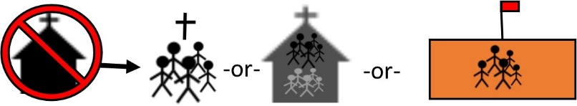

- Field Ed Model aka “Mutual Learning”

Ideal for congregations willing to take on a seminary student in limited preaching and pastoral engagement, and for those willing to mentor and be mentored in ministry.

- Commissioned Lay Pastor / Commissioned Ruling Elder (CLPs / CREs)
aka “Yup, ruling elders can do that.”

Ideal for congregations willing to accept specially trained elders from another PCUSA congregation who are called to serve as part-time temporary pastor with experience outside of classical seminary training.

- Celebration of the Completion of Your Ministry
aka “Well done, good and faithful servants…”

Ideal for congregations ready to celebrate their legacy and write the final chapter of their church story.

